ATTENTION!!!
A LARGE AMOUNT OF HORSE TACK HAS BEEN STOLEN FROM EAST HAGBOURNE
FRIDAY 6TH NOV 09
BETWEEN 5.30PM – 10.30PM
THE TACK WAS STOLEN FROM A PADDOCK ALONG MAIN ROAD JUST BY BRIDGE BETWEEN COSCOTE AND EAST HAGBOURNE PRIMARY SCHOOL – (this is a popular area for dogwalkers and ramblers)
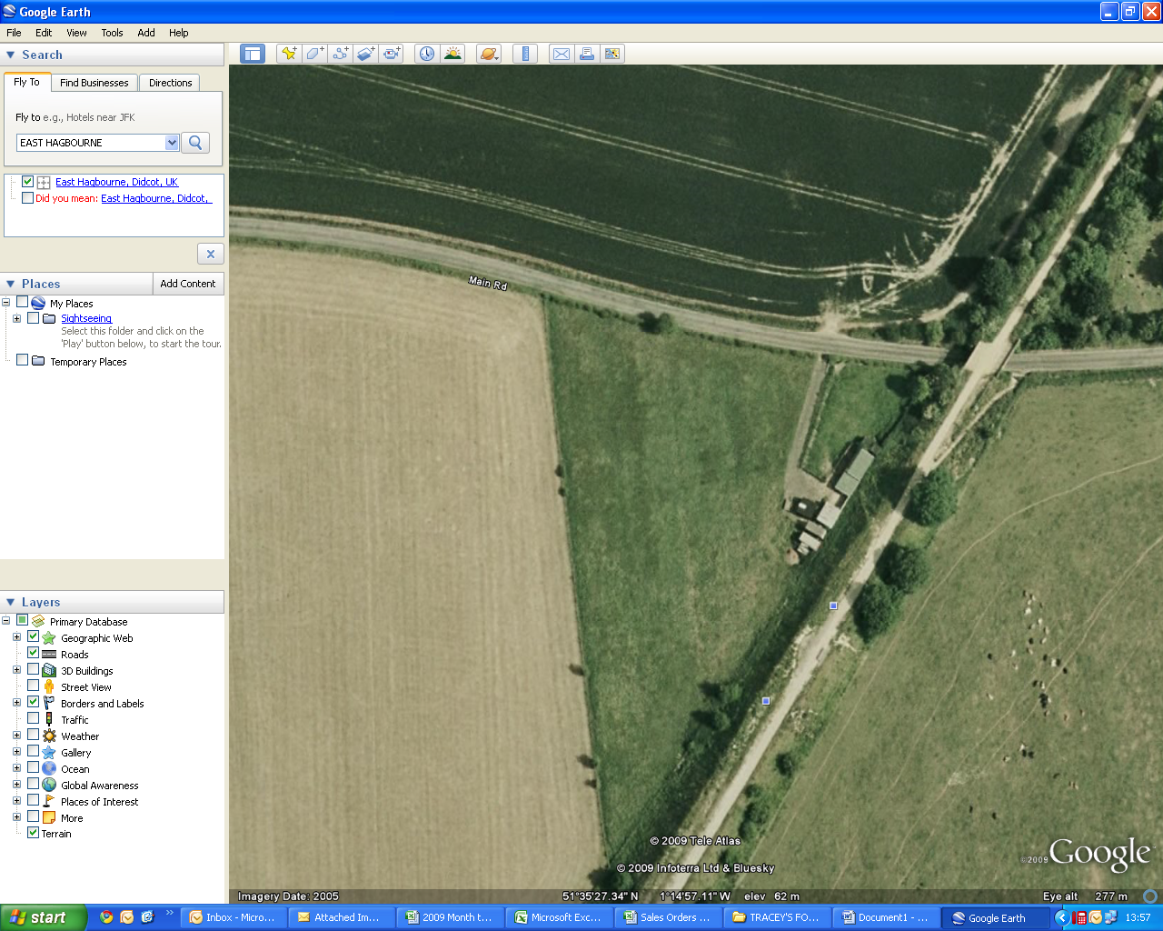
Embankment
Bridge
Main Road towards Coscote
A WHITE VAN WAS SPOTTED PARKED IN THE OPPOSITE FIELD.
WERE YOU WALKING/CYCLING ALONG THE EMBANKMENT THAT EVENING ?
DID YOU SEE THIS VEHICLE/TORCH LIGHTS/PEOPLE OR ANYTHING UNUSUAL OR SUSPICIOUS?
IF SO PLEASE CONTACT: 07900156807
CALLS WILL BE TREATED IN TOTAL CONFIDENCE
ANY INFORMATION PROVIDED CAN AND WILL HELP

