West Hagbourne Village Association

St. George’s Day Celebration Event
13th-26th April 2020
St George & Dragon Displays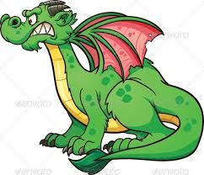

The theme for this year’s competition is St. George’s Day.
You are invited to create an exhibit of
your choice to be displayed between the 13th and 26th April,
during which time judging will take place.

Prizes will be awarded as follows:
Best display - £30.00
Runner- up - £20.00
Best child’s entry - £10.00

As we are unable to hold the afternoon teas and walk events this year, the winners of the competition will be contacted individually and the results
then posted on the village website.

Children are also invited to draw or paint a picture of St George
and/or the dragon to display in their front window during the same 2 weeks.

If you require more information,
please contact the Association Chair, Margaret Leishman,
Tel: 01235 851707 or email: va@westhagbourne.org

Thank you for your support!

